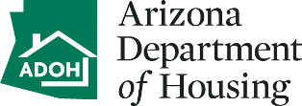
NEIGHBORHOOD REVITALIZATION STRATEGY (NRS)

STATUS REPORT

Complete the items below and on the attached form to describe the Neighborhood’s progress in the implementation of the Strategy during the prior year. An example is included for reference.

Grantee: CDBG Contract No:
NRS Area Name: Report Prepared By:
For Year: Date Prepared:

1. Status of the Local Advisory Committee:
[ insert narrative explanation on the status of the Local Advisory Committee]

2. Status of Program Linkages to include funding applications submitted:
[insert narrative explanation on Program Linkages and any applications submitted for other funding sources]

3. Problems/Barriers encountered:
[ insert narrative explanation on any problems or barriers experienced]

NEIGHBORHOOD REVITALIZATION STRATEGY (NRS)
STATUS REPORT

Priority | Goals/Strategies | Status | Start | Finish

