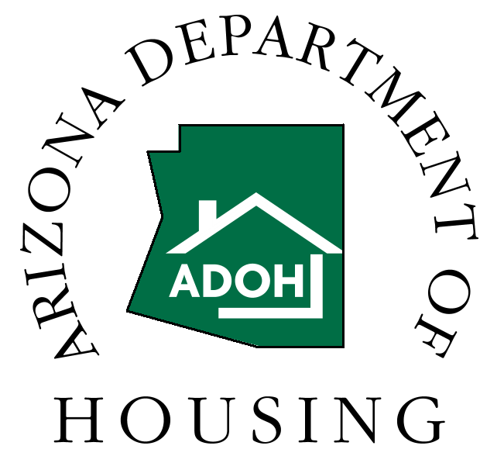
CDBG FILE CHECKLIST
AFFIRMATIVELY FURTHERING FAIR HOUSING (AFFH)

Community:______________________________________ Calendar Year:______________

Check/Date Item

_________ Resolution or Proclamation (*)

__________ Assessment, with information about status of such, committee members, meeting notices or public hearings, minutes/notes and list of attendees

__________ Press Releases

__________ Brochures and distribution/mailing list

__________ Location of Posters and distribution list for same (*)

__________ A copy of the State and Federal Fair Housing Law

__________ A copy of the section of the Consolidated Plan applicable to AFFH

__________ Copies of newspaper articles

__________ Poster or essay contest information

__________ Letters to real estate licensees and a mailing list

__________ Letters to housing lenders and a mailing list

__________ Notices of AFFH training, public meetings, workshops; a list of attendees

__________ PSAs and a mailing list

__________ Information about housing discrimination complaints and the disposition of each,
e.g, referral to the Attorney General

__________ Contacts made (by telephone) with groups interested in providing AFFH training or
workshops

_________ Other

(*) = required action. The other items listed are samples of AFFH activities. You must complete at least three, including the two required actions.

A checklist for each calendar year a community is eligible for CDBG funds regardless of if they have any open contracts must be retained.

